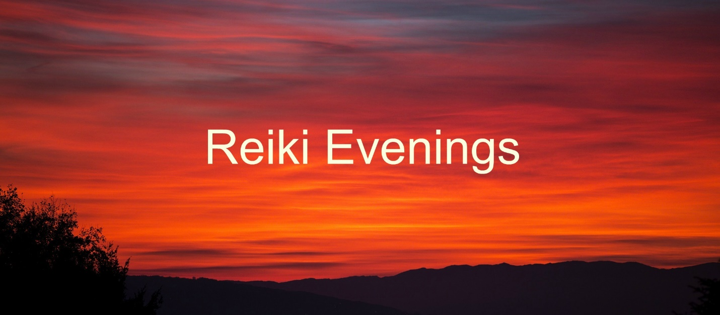

Kristin, Jennifer, Leslie, Pam, Carrie, Susan, Laura and Elizabeth,

Welcome to Reiki Evenings!
I am so excited for our first meeting, this coming Monday. What a wonderful group of women! I look forward to the creation of our circle, joining hearts, and starting out the journey through the seasons together.
We will spend some time talking about “Reiki and Healing the World”; enjoy a grounding meditation; and have our first Reiki Share.
A few details…

Monday, September 25th
6:30 – 9:30 pm
Almus Reiki Space, 6951 SW 33rd Ave.
(Enter through the gate between the house and garage, take a right to the door under the deck.)
- Please arrive a few minutes early, so that we can start right on time.
- Dress comfortably and in layers, including socks.
- Feel free to park behind my car in the driveway, or just east a block near the park.
- Please let me know if you have any food allergies or preferences.
- Let me know if you will NOT be able to join us.

Love,
Judi

